1. Understand the data and the discrepancies associated with it.

* File type states ‘Microsoft Excel Comma Separated Values file’ i.e. csv, However contents are of type of ‘Microsoft Excel Worksheet’.

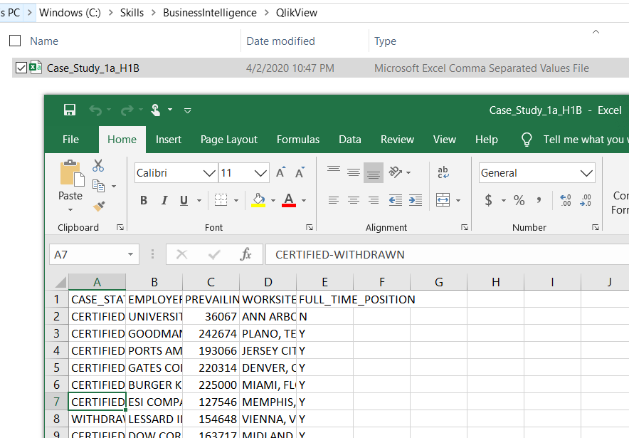

So, in QlikView File Wizard also not capturing details as expected.

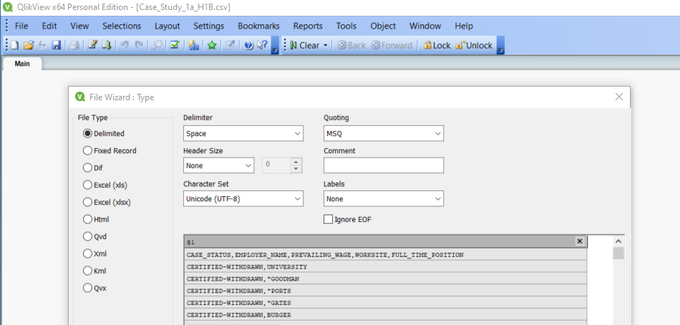

**Solution: Change File type and then import data in QlikView**

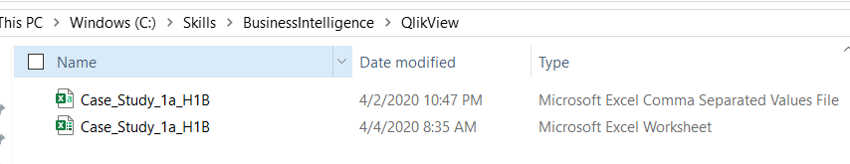

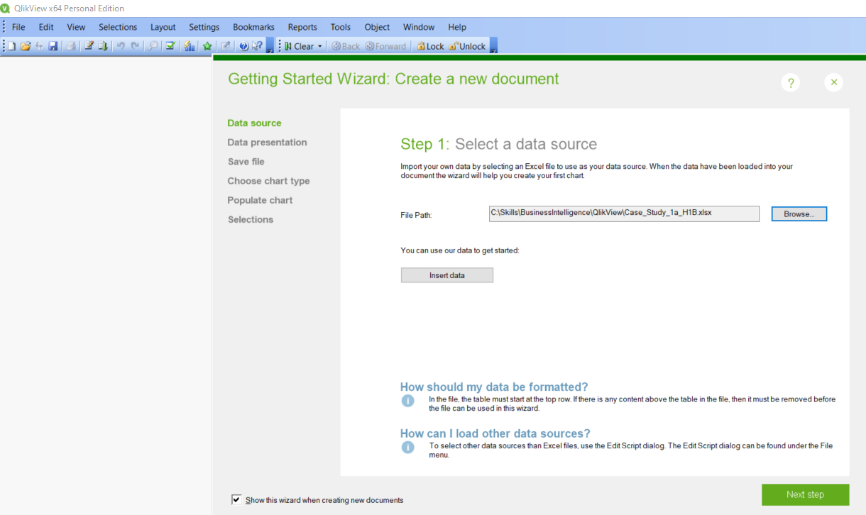

1. Analysis based on CASE_STATUS

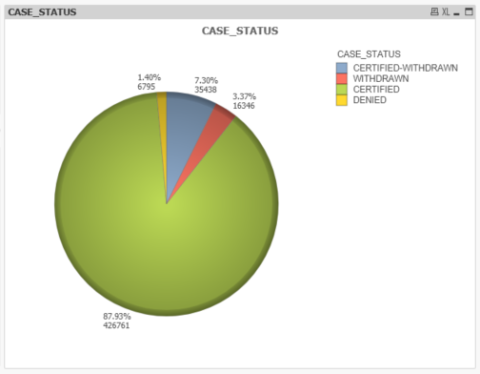

* 1. What % of cases are CERTIFIED – **87.93%**
  2. How many cased were DENIED – **6795**

1. Analysis based on EMPLOYER_NAME
   1. Top 10 Employer filing for H1B visa, what can you infer from it?
   * **Below Char shows Top 10 employer filing number of H1B Visas.**

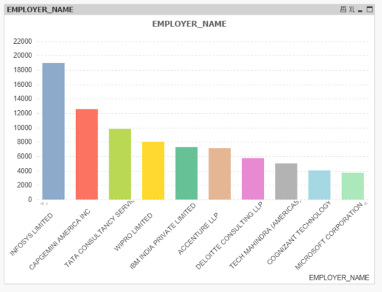

* 1. Top 5 Employer whose visa application are denied maximum number of times.

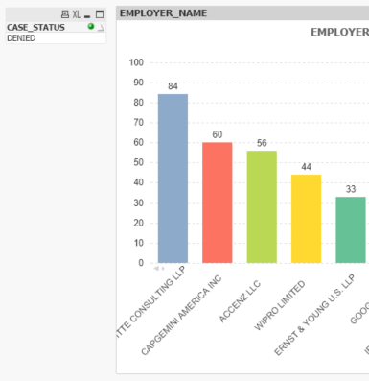

1. Maximum number of visa application are certified for which WORKSITE.
   * **NEW YORK, NEW YORK**

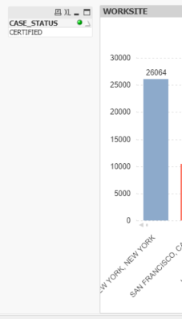 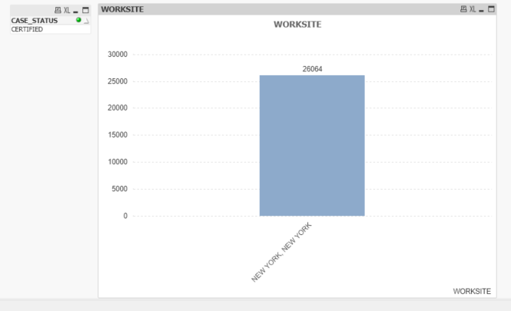

1. Approximately what % of certified visa application are for part time position, considering top employer and for worksite which we identified in Q4.
   * **98.25%**

